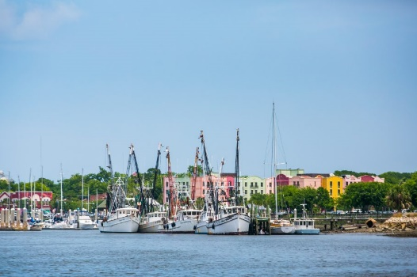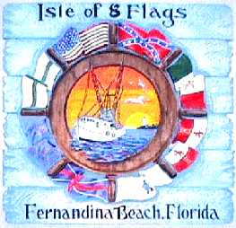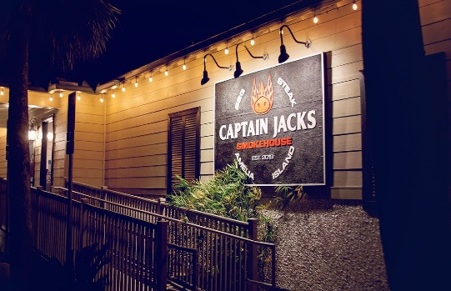

Please join us in Jacksonville, Florida for the 2021 Pre‐Convention Tour on Thursday, May 20, 2021!

We travel by motor coach to Fernandina Beach on Amelia Island, the northernmost city on Florida's Atlantic Coast. First inhabited by the Timucuan Indian tribe and known as the "Isle of 8 Flags", Fernandina has had the flags of the following nations flown over it since 1562: France, Spain, Great Britain, Spain (again), the Patriots of Amelia Island, the Green Cross of Florida, Mexico, the Confederate States of America, and the United States. It is the only municipality in the United States that has flown eight different national flags.

At 10 AM, we take the Cumberland Island boat tour, which offers an extensive and rich history of Amelia and Cumberland Island with views of wildlife along the way. As we cruise by Fernandina’s shrimp boats, historic Old Towne and Ft. Clinch, a historian will share colorful stories that define the character of this unique area.

We will have lunch at Captain Jack’s Smokehouse before returning to our hotel.
The price per person is $95 ($93 if over 65) and includes transportation, the boat tour, and lunch.
We will leave the Doubletree Hotel at 8 AM and the bus will take us to Fernandina, where we will have our boat tour and lunch. We will be back to the hotel by 4:00 PM.

Number of Tickets ____________ Number of Tickets (over 65) ______________
NAME ADDRESS CITY STATE ZIP CODE CHAPTER (or Member-at-large)
Amount enclosed ______________________

Please make check payable to NARBW Jacksonville and mail to
Barbara Miller
NARBW Pre-Convention Tour
929 Mystic Harbor Drive
Jacksonville, FL 32225

